Tectonique I

Partie II : Les structure continentales
Chapitre 1 : Plate-forms and Shields
Platforms:
In geology, a platform is a continental region made up of a sedimentary cover (relatively flat or slightly inclined strata) overlying a very ancient basement of metamorphic or igneous rocks.
Shields:
A shield is a stable region of ancient basement composed of rocks of magmatic and metamorphic origin dating from the Precambrian (between 570 million and several billion years old). These are large, generally flat regions, leveled by erosion, and with low seismic activity. Shields do not have any sedimentary cover; otherwise they are referred to as platforms (fig. 1).
Platforms, shields and the basement rocks together constitute cratons.
Cratons:
A craton is an old and stable part of the continental lithosphere, which consists of Earth's two topmost layers, the crust and the uppermost mantle.
Shields make up most of the surface of continents. They are divided into two large groups located at high and low latitudes.
That of high latitudes includes the Fenno-Scandian, Russo-Siberian, Canadian and Antarctic shields.
At tropical and subtropical latitudes, we encounter those of Africa (in Algeria, the Targui shield at Hoggar and the Reguibat shield at Eglab), Madagascar, Arabia, Dekkan, Australia, South America. This last set, the most extensive, represents elements inherited from a very vast continent which existed until the end of the primary era, the continent known as Gondwana, a name taken from a region of the Dekkan inhabited by the Gonds. .

Figure 1 : Les bouclier Tergui et Reguibat et la plateforme saharienne en Algérie
Les principaux boucliers (Figure 02)
• Bouclier amazonien
• Bouclier de l'Angara
• Bouclier antarctique
• Bouclier arabe
• Bouclier australien
• Bouclier canadien
• Bouclier éthiopien
• Bouclier scandinave
• Bouclier ukrainien

The Tergui Shield (bouclier Tergui)
The Targui shield, also called the Hoggar massif, is located in the south of Algeria with an area of more than 500,000 km2 (fig. 2). The Hoggar forms an ancient craton with a complex history. It essentially includes Archaean, Paleoproterozoic and Neoproterozoic formations unconformably overlaid by sedimentary formations from the Taoudeni basin. It is structurally subdivided into 3 main areas:
-The Western Hoggar:
The Western Hoggar results from the collision, in Pan-African (630-570Ma), between the West African Craton and the Touareg Shield. It includes an Archaean core (the In Ouzzal mole, equivalent of the Adrar des Iforas further south in Mali), stabilized and cut by granites since 2 Ga. It is surrounded by younger formations (Mesoproterozoic, Neoproterozoic, Cambro-Ordovician, Silurian, Devonian, Cretaceous and Tertio-Quaternary).
The Archaean mole of In Ouzzal is made up of gneisses, charnockites, cipolins and ferruginous quartzites (BIF).
The Mesoproterozoic formations include marbles, amphibolites, quartzites, mica schists and, locally, intrusions with komatiitic composition.
The Neoproterozoic formations include meta-pelites, marbles, dolomites and quartzites, interspersed with sills of basic-ultrabasic rocks and locally andesitic flows. They are cut by two intrusive phases of granitoids, the first at 870-840 Ma (Neoproterozoic) and the second at 650 Ma (Pan-African), (Tin Tékadiouit granite, Immezzarène). These formations are covered by the upper green volcano-sedimentary series: andesitic lavas, turbidites, graywackes and cut with Pan-African batholiths.
The polycyclic central Hoggar of Eburnean, Kibarian and Pan-African age includes formations of Archean age (the oldest dates go back to 3.3 Ga) to Paleoproterozoic and Mesoproterozoic, affected by three orogenies (Eburnean: 2 Ga, Kibarian: 1 Ga and Pan-African: 560 Ma).
The Archean to Paleoproterozoic basement (Issalane mole) includes meta-sediments (pelites and marbles), meta-basites, migmatites and gneisses (granodioritic to tonalitic). The Mesoproterozoic is made up of marbles, cipolins, amphibolites, quartzites and mica schists. The main N-S accidents are punctuated by volcano-sedimentary and plutonic series from the Neoproterozoic. Its western limit coincides with the great fracture 4°50 and its eastern limit being formed by the granite axis of HONAG.
- The eastern Hoggar:
It is characterized by the Tirririnian chain of late Pan-African age, includes the Issalane mole, the Tiririnian furrow and the Djanet – Tafassaset zone. The Eastern Hoggar is made up of three formations:
Protoliths of Archaean granito-gneissic base, made up of meta-sediments (pelites, marbles), meta-basites and migmatites;
A volcano-sedimentary series, including basalts, rhyodacites and black clastic and pelite sediments recrystallized in the green schist facies;
Strips of ophiolites and granodiorites (the latter dated at 725 Ma), which intersect the previous sets. These formations are covered, in unconformity, by the thick Tirririne series (more than 8000m; 660-585 Ma) which includes: at the base, the dolomite-sandstone-jasper trilogy (jasper often corresponding to meta-rhyolites) and at the top, turbidites, sandstones, conglomerates, arkoses, and graywackes, all capped by fluvial sandstones.
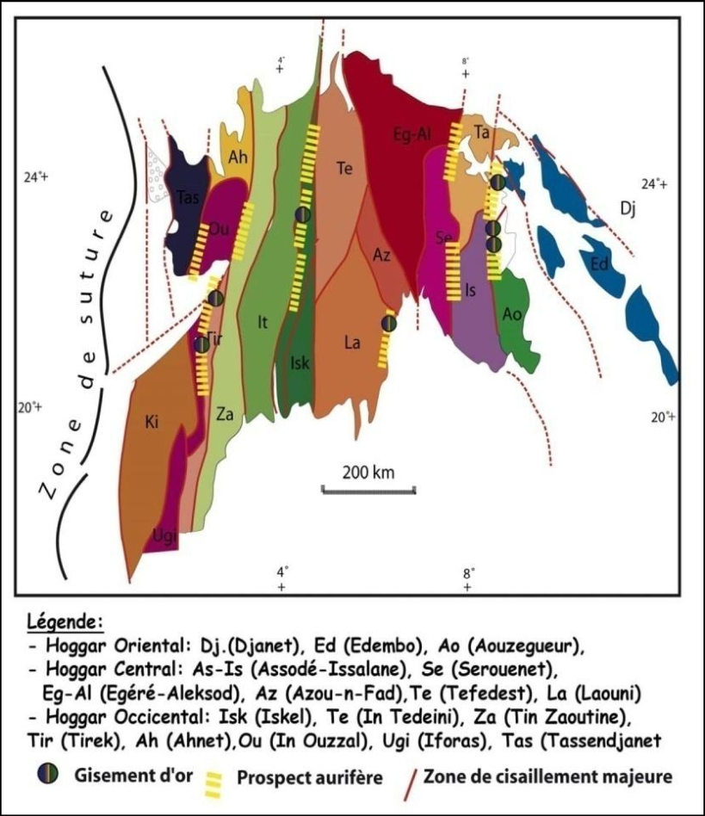
Figure 2: Tergui shield (bouclier tergui)

Canadian Shield (Bouclier canadien)
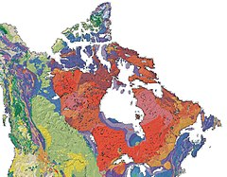
The Canadian Shield also called the Laurentian Plateau, is a large geographic area located in eastern and central Canada (fig. 3). It is a geologic shield, a large area of exposed Precambrian igneous and high-grade metamorphic rocks. It forms the North American Craton (or Laurentia), the ancient geologic core of the North American continent. Glaciation has left the area with only a thin layer of soil, through which exposures of igneous bedrock resulting from its long volcanic history are frequently visible.^{[3]} As a deep, common, joined bedrock region in eastern and central Canada, the Shield has roughly a U shape and stretches north from the Great Lakes to the Arctic Ocean, covering over half of Canada and most of Greenland; it also extends south into the northern reaches of the United States. It covers 4.8 million km².
Figure 3. The Canadian shield
The Scandinavian Shield
The Scandinavian Shield, Baltic Shield or Fennoscandian Shield is a predominantly granitic geological formation covering Fennoscandia, the Baltic countries and north-west Russia. It comes from the paleocontinent Baltica (fig. 4). This shield is characterized by a western edge raised at the level of the Scandinavian Alps and by a large central depression occupied by the Baltic Sea and its watershed resulting from the sinking of the earth's crust under the weight of the ice cap present over the entire shield during the Würm glaciation. The Scandinavian Shield is one of the regions of the globe most subject to isostatic rebound which causes a gain in altitude of all areas of the shield and in particular the bottoms and coasts of the Baltic Sea.
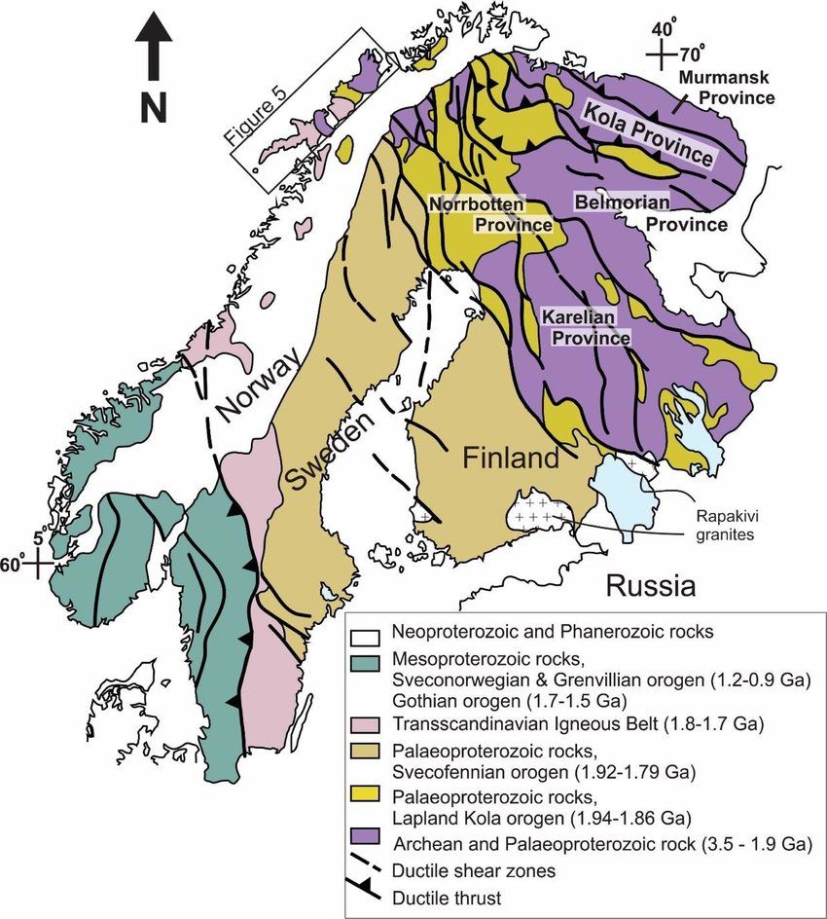

Figure 4. Geological overview map of the Fennoscandian shield in Scandinavia.

Ukrainien shield
From a geographical point of view, the Ukrainian shield is the region of the gigantic plain
from Eastern Europe where the Precambrian crops out; it occupies approximately half of the territory of Ukraine. The landscape of the Ukrainian shield appears as a succession of valleys or hills, which originates 100-200 km north of the Black Sea and extends over a distance of approximately 700 km to the Polish border. The Podolie plateau, belonging to the same formation, presents a more marked relief.
In geology, we call the “Ukrainian shield” a Precambrian massif outcropping in the center and at western Ukraine. This very stable massif from the point of view of plate tectonics was formerly attached to the Fenno-Sarmatic paleo-continent, which collided with Laurasia in the Silurian (more than 440 million years ago). These very ancient formations constitute a shield where crystalline rocks dominate, and which stands out from the Central Plateau of Russia, neighboring to the east and formed of recent sediments. The Ukrainian Shield is the easternmost remnant of the Hercynian orogeny. The neighboring plateaus of Russia and Scandinavia are linked to the Caledonian orogeny which is posterior to them.
The Arabian-Nubian Shield (ANS)
The Arabian-Nubian Shield is an exposure of Precambrian crystalline rocks on the flanks of the Red Sea (fig. 5). The crystalline rocks are mostly Neoproterozoic in age. Geographically and from north to south – the ANS includes parts of Palestine, Jordan, Egypt, Saudi Arabia, Sudan, Eritrea, Ethiopia, Yemen, and Somalia.
The ANS in the north is exposed as part of the Sahara Desert and Arabian Desert, and in the south in the Ethiopian Highlands, Asir province of Arabia and Yemen Highlands.
The ANS was the site of some of man's earliest geologic exploration and exploitation, principally by the ancient Egyptians to extract gold from the rocks of Egypt and NE Sudan.
This was the most easily worked of all metals and does not tarnish.
All of the gold deposits in Egypt and northern Sudan were found and exploited by Egyptians.
The earliest preserved geologic map was made in 1150 BCE to show the location of gold deposits in Eastern Egypt; it is known as the Turin papyrus. New gold discoveries have been found in Sudan, Eritrea, and Saudi Arabia.
Pharonic Egyptians also quarried granite near Aswan and floated this down the Nile to be used as facing for the pyramids. The Greek name for Aswan, Syene; is the type locality for the igneous rock syenite. The Romans followed this tradition and had many quarries especially in the northern part of the Eastern Desert of Egypt where porphyry and granite were mined and shaped for shipment.
Precious and industrial metals, including gold, silver, copper, zinc, tin, and lead, have been mined in Saudi Arabia for at least 5,000 years.
The most productive mine in Saudi Arabia, Mahd adh Dhahab ("Cradle of Gold"), has been periodically exploited for its mineral wealth for hundreds or even thousands of years and is reputed to be the original source of King Solomon's legendary gold. Today, mining at Mahd adh Dhahab is conducted by the Saudi Arabian Mining Company, Ma'aden. Deposits of iron, tungsten, mineral sands, copper and phosphates have been found in many locations. Mining in the Eastern Desert of Egypt and Sudan is limited due to a shortage of water and infrastructure.
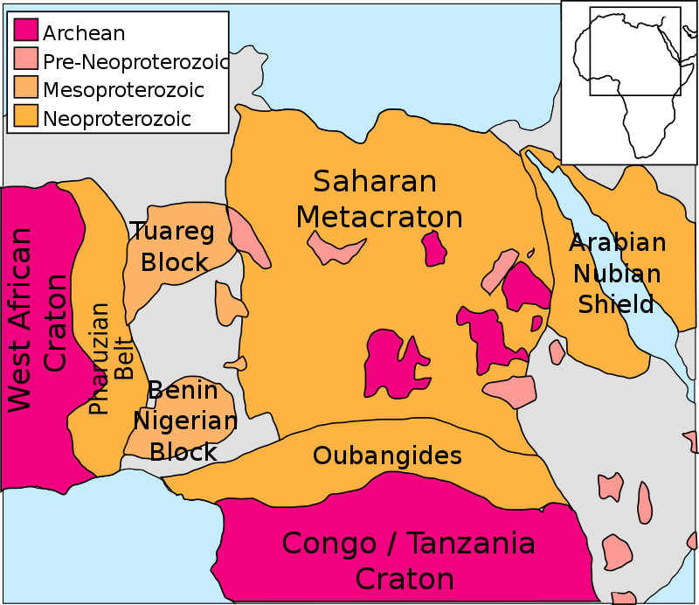
Figure 5. Extent of the Arabian-Nubian Shield. To the west it borders the Saharan Metacraton. Colors indicate the age of the rocks (Archean, Pre-Neoproterozoic, Mesoproterozoic, Neoproterozoic).
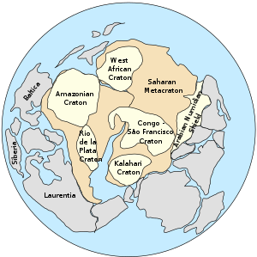
The Arabian-Nubian Shield in the supercontinent Pannotia c. 570 million years ago, before the opening of the Red Sea.

Development of the Arabian-Nubian Shield

The Arabian-Nubian Shield (ANS) is the northern half of a great collision zone called the East African Orogeny.

This collision zone formed near the end of Neoproterozoic time when East and West Gondwana collided to form the supercontinent Gondwana.

The East African orogeny extends southward to the Mozambique Belt, and is a subset of the overall Pan-African orogeny. The assembly of Gondwana coincided with the breakup of Rodinia, closure of the Mozambique Ocean, and growth of the shield at 870 million years ago (Ma). This shield growth extended for the next 300 million years, and included island arc convergence and terrane suturing at 780 Ma, with final assembly by 550 Ma. At this time, the East African Orogen became a passive margin and the southern shore of the Paleo-Tethys Ocean.
A number of features have been ascribed to late stage extensional tectonics including a widespread northeast trending dyke swarm, northeast–southwest trending normal faults and northwest–southeast trending sedimentary basins filled with post-orogenic molasse deposits
Crustal weaknesses before 500 Ma influenced continental rifting, as the Arabian peninsula moved away from Africa, and the formation of the Red Sea Basin at the start of the Oligocene. By then, some of the Paleozoic and Mesozoic rocks had been eroded, if ever deposited. In fact, the 1,200 km (750 mi) wide ANS orogenic belt, has a present-day layered crustal structure, with a uniform Moho depth of 35–45 km (22–28 mi). Post-rift deposition of evaporites occurred until the Pliocene, when a marine environment took over.

