Tectonic I

1.1 What is tectonics?

Tectonics is the discipline of Earth Sciences which deals with deformations of the earth's crust. From the Greek “Tektonikos”, specific to the carpenter, to the architect. It therefore implies a notion of structure.

Structural Geology is often used synonymously with Tectonics. Structural Geology is essentially the study of the geometry of structures. Tectonics (“Tectonics”) rather concerns the study of these structures in relation to the movements (Kinematics) and the forces (Dynamics) which created them.
Both tectonics and structural geology have developed rapidly since the 1960s. Tectonics has undergone a revolution based largely on the formulation of the theory of plate tectonics. This theory now provides the framework for the study of almost all large-scale motions and deformations affecting the Earth's crust and mantle.
Geophysical methods such as seismic, magnetic, and gravity provide information on the geometry of large-scale structures at depth, which adds the critical third spatial dimension to our observations.
Studies of magnetism and paleo-magnetisme as well as seismology provide data on the past and present geometry and motions of plates that are essential for reconstructing global tectonic patterns. Heat flow and geothermal data provide information on temperature distribution within the Earth, which bears upon possible patterns of convective flow in the Earth's mantle.
Tectonics also depends on other branches of geology. Petrology and geochemistry provide data on the temperatures, pressures, and ages of deformation and metamorphism, which permit accurate interpretation of deformation and its tectonic significance.
Sedimentology and paleontology are also important in reconstructing the patterns and ages of tectonic events.
1-The earth's crust and the lithosphere
The deep seismic exploration and the analysis of earthquake seismic waves have enabled scientists to subdivide the superficial part of our terrestrial planet into two large superimposed layers:
– An outer layer called the crust or earth’s crust (on average 30 km thick under the continents and less than 10 km under the oceans);
– An underlying mantle, separated from the earth's crust by a discontinuity surface called the Mohorovicic discontinuity (the Moho).
We note that the superficial part of our globe is rigid (with a thickness of around 100 to 200 km). This part of the globe is the lithosphere (crust and top of the upper mantle). Below the lithosphere comes immediately the asthenosphere where seismic velocities decrease, at least in its upper part. This low-velocity (asthenosphere) zone corresponds to material likely to deform easily and which is probably the level at which isostatic readjustments as well as the convection cells occur and which is believed to drive many orogenic phenomena.
On the surface, the lithosphere can be of two types, continental or oceanic.
I 2- THE CONTINENTAL CRUST
In the stable continental zones, which correspond to large shields and platforms like that of Africa or Russia (which have not undergone deformation for several hundred million years) we distinguish:
– The upper crust (10 to 15 km), d = 2.7, Vp = 6 km/s. encountered under a variable thickness of sediments (0 to 1.7 km), it always shows more or less granitized gneisses, hence its name granito-gneissic (or sialic) layer. This upper crust in fact largely outcrops in the large shields and is found, sometimes visible over its entire thickness and in ancient and current mountain ranges.
– The lower crust (10 to 15 km), d = 2.8 to 2.9, Vp = 7 km/s.
Between these two layers, there is sometimes a zone where seismic P-wave velocities vary from 6 to 5.5 km/s; it is the discontinuity of Conrad. The lower crust is more difficult to interpret, because it is inaccessible in great shields. The lower crust would be made up of intrusions of mantle material, basic to ultrabasic, within a series of sedimentary origin metamorphosed, as has been said, under eclogite to amphibolite facies.

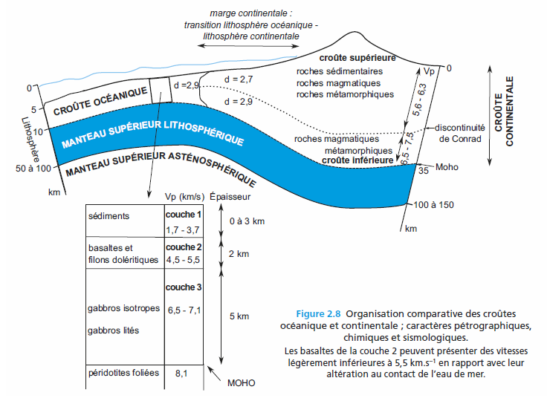
Figure 1. Structure de la croute continentale et océanique
I 2- The oceanic crust
It forms the bottom of the great oceans and essentially differs from the previous one (the continental crust) by its thinness and the absence of a granite-gneissic layer. It is made up of:
- A layer of sediment of variable thickness 0 to 3 km:
– The upper oceanic crust, the only one reached by drilling, its thickness is approximately 2 km, d = 2.5 to 2.7, Vp = 5 km/s. It shows basaltic flows containing some consolidated sedimentary levels.
– The lower oceanic crust. Thickness 5 km, d = 2.8 to 2.9, Vp = 7 km/s. Its nature is debated since the drilling did not reach it. It is essentially made up of basalts, metamorphosed gabbros, amphibolite and serpentinized peridotites. This lower oceanic crust is made up from top to bottom of (fig.2):
– A massive dolerite layer, made of a tight swarm of basaltic dikes, having obviously fueled the overlying volcanism;
– A gabbroic set, with a cumulate texture1;
– Ultrabasic banded cumulates (more or less serpentinized peridotites) which form the base of the oceanic crust, because below come the peridotites of the upper mantle, very different from the previous ones by their tectonite texture.
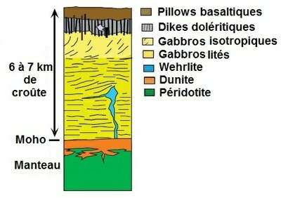
A. Section of a classic ophiolite sequence.
B. A typical ophiolitic set observed in certain sectors of the French-Italian Alps.
It is characterized by the extreme reduction of pillow basalts and gabbros (the serpentinized peridotites then forming the ocean floor) and the appearance serpentine breccias with white calcite cement (ophicalcites) whose origin (sedimentary or hydrothermal) remains debated. Thickness of the section = approximately 1 km.
C. The Goringe Bank, off the coast of Portugal (see fig. 4.10). This is a panel of oceanic lithosphere tilted by approximately 20°, located in the vicinity of the fracture Azores-Gibraltar. It made it possible, through direct observation in a submersible, to reconstruct a section of the Atlantic oceanic crust. The alkaline volcanics of top of the cut were put in place later and have nothing to do with the oceanic crust itself.
Figure 2 : Constitution de la croute océanique

I 2 1 Landforms of the oceanic crust
Like the earth's crust, the oceanic crust has different reliefs. Here are a few :
1-Oceanic or mid-oceanic ridges: These are elevations on the ocean floor fig. (2), which can reach 3000 meters in altitude. They are generally found on the edges of tectonic plates and are associated with underwater volcanoes because they have a central groove through which magma flows continuously. Ocean ridge systems renew ocean crust, generating on average 17 cubic kilometers of ocean crust per year.
2-Abyssal Plains: These are flat extensions located between 3000 and 6000 meters under the ocean water surface. It is estimated that abyssal plains represent 50% of the ocean floor and that there are several landforms similar to existing landforms in the continental crust (fig. 2).
3-Guyots: They are considered flat-topped seamounts. It is believed that at one time they were at sea level and that is why their peaks were eroded until they became flat.
4-Trenches: These are narrow but deep cracks in which large amounts of sediments accumulate. They are found on the edges of tectonic plates or near a continent or an island (fig. 4). One of the most famous trenches is the Mariana Trench.
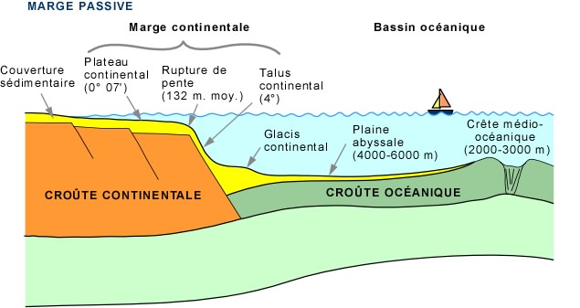
Figure 3, Coupe dans la croute océanique montrant les différents reliefs océanique
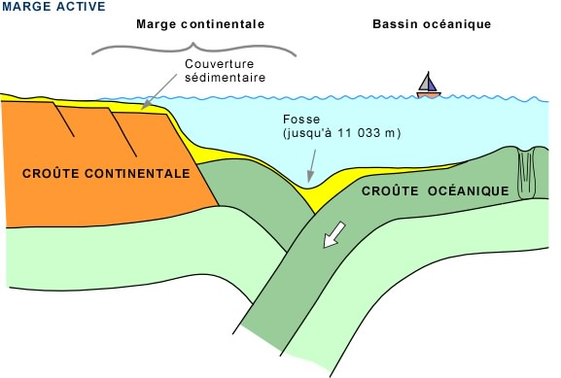
Figure 4, longitudinal cross-section showing an oceanic trench (Trench)
I 3 1 Differences between oceanic crust and continental crust
The earth's crust can be differentiated into continental crust and oceanic crust, each having its own characteristics and particularities. The main differences between them lie in their composition and density.
In principle, the oceanic crust is composed, as we have already mentioned, of basaltic rocks, while the earth's crust, although it has a heterogeneous composition, it is composed mainly of granite-type rocks, with large percentages of aluminum and silicon.
Another point is density; oceanic crust is denser than continental crust. As we developed in previous sections, the difference in density allows the oceanic crust to be in a constant recycling process. This phenomenon determines the age of the different crusts, with oceanic crust being considerably younger than continental crust.
Finally, another difference is the thickness of the two crusts: the oceanic crust has a thickness of 8 to 10 kilometers while the continental crust has a thickness of 30 to 70 kilometers.
I 4 1 Lithosphere and isostasy
The regulating mechanism of the irregularities in the distribution of terrestrial reliefs of the crust above the mantle, e.g.: mountains, abyssal plains, continental shelves, etc., is of the hydrostatic type, that is to say, the crust “floats” on the mantle. Any relief of the continental crust is compensated by a “root” of this same crust sinking into the mantle, exactly as shown by an iceberg in the sea. This comparison is all the more justified as the ratio of densities of the two environments present. This hydrostatic balance is called isostasy.
Seismological studies have confirmed the existence of these roots which can reach up to 70 km deep and therefore double the thickness of the normal crust under certain mountain ranges.
As for the oceanic crust, it is only 7 km thick and would thus compensate for the low density of the overlying water. Such a regulating mechanism implies that there is, at depth, a fluid medium, even if this fluid is extremely viscous. For a long time, it was believed to be the upper mantle. We now know that this is the asthenosphere.
Isostatic phenomena must therefore be examined on the scale of the lithosphere and no longer of the crust alone. However, from this point of view, we see that there are two types of isostatic compensation.
If the lithosphere is thick and rigid: regional compensation, ex: Himalayas, Haway
If the lithosphere is less rigid: less significant regional compensation, Tibetan plateau

