Module: Management of household and similar waste
Lesson 2: Waste Management
Teacher responsible for the module: Guemini Nassira
---------------------------------------------------------------------
1- Definition
Waste management is the process of collecting, transporting, treating, recycling, and disposing of waste materials in a safe manner to reduce their negative impact on human health, the environment, and urban aesthetics.
2-General Principes of Waste Management
the general principles of waste management that guide effective and sustainable handling of waste:
1. Waste Prevention & Minimization
- Reduce the amount of waste generated at the source (e.g., eco-design, efficient resource use, avoid single-use products).
2. Polluter Pays Principle (PPP)
- Those who produce waste are responsible for bearing the cost of its management and disposal.
3. Precautionary Principle
- Take preventive measures to avoid environmental harm, even if there is no complete scientific certainty about risks.
4. Sustainable Development Principle
- Manage waste in ways that protect current needs without compromising resources for future generations.
5. Integrated Waste Management
- Use a mix of strategies (reduce, reuse, recycle, recover, treat, and dispose) for efficient and safe handling of waste.
6. Circular Economy Approach
- Treat waste as a resource by recycling, reusing, and recovering materials to keep them in the economic cycle.
7. Proximity Principle
- Waste should be managed as close as possible to its source to reduce transport costs, emissions, and risks.
8. Public Participation & Awareness
- Engage communities in waste reduction, segregation, and recycling efforts through education and involvement.
9. Environmental & Health Protection
- Ensure that waste management practices do not endanger human health or harm ecosystems.
10. Hierarchy of Waste Management (3Rs → 5Rs)
- Reduce → Reuse → Recycle → Recover → Dispose
- Disposal (landfill/incineration) is the last option after all recovery and recycling methods are applied.
In short: The general principles of waste management focus on reducing waste generation, ensuring safe disposal, promoting recycling and recovery, protecting health and the environment, and making producers responsible for their waste.
3- Steps of waste management
1-Pre-collection
2-Collection
3-Transportation
4-Sorting
5-Treatment
6-Storage
7-Disposal / Recovery (Valorization)
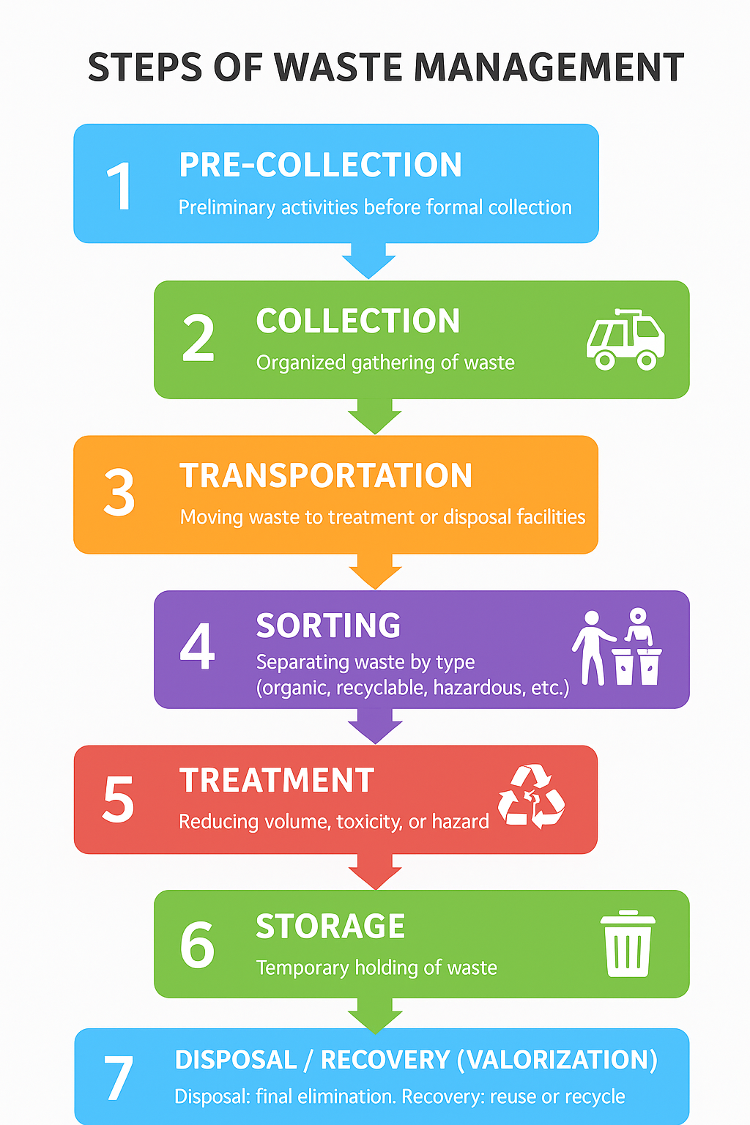
1. Pre-collection
- All activities before formal collection, such as temporary storage at households, institutions, or businesses and sometimes community-based gathering in bins or containers.
2. Collection
- The organised gathering of waste from households, industries, commercial areas, and institutions by municipal services or private companies.
3. Transportation
- Moving the collected waste to transfer stations, treatment plants, or disposal sites using trucks or specialised vehicles.
4. Sorting
- Separating (segregation)waste by type (organic, recyclable, hazardous, etc.) to allow for recycling, composting, or safe treatment. Sorting can be done at the source or at specialised facilities.
5. Treatment
- Processes used to reduce the volume, toxicity, or hazardous nature of waste. Examples: composting, incineration, anaerobic digestion, or chemical treatment.
6. Storage
- Temporary holding of waste (treated or untreated) in safe conditions before final disposal or valorization. This prevents pollution and health risks.
7. Disposal / Recovery (Valorisation)
- Disposal: final elimination of waste, usually in sanitary landfills or controlled dumping sites.
- Recovery (Valorization): extracting value from waste, such as recycling materials, producing energy, or reusing resources.

In short: Waste management is a chain of steps, starting with pre-collection and ending with either safe disposal or valorisation to recover useful resources.

Module: Management of household and similar waste
Tutorial Work N 02: Waste Management
Teacher responsible for the module: Guemini Nassira
-----------------------------------------------------------------------
waste management in Algeria:
Key Statistics & Facts
Item | Data / Description
Total Household Solid Waste (HSW) | Algeria produces about 13.5 million tonnes/year of HSW. Revistas USC+2Algeria Invest+2
Annual Waste Growth Projection | Under business-as-usual, HSW could reach ≈ 23 million tonnes by 2035. If Algeria implements waste prevention, recycling, incentives etc., this could be limited to ~ 20.5 million tonnes. Revistas USC
Recycling Rate of Household Waste | Currently low: around 7-10% of household solid waste is recycled. Best Practices Waste Med+2MDPI+2
Composition of Waste | The breakdown of municipal solid/household waste:  • Organic / biodegradable waste: ~ 54-63% Tore+2Best Practices Waste Med+2  • Plastics: 15-18% Best Practices Waste Med+1  • Paper/cardboard: ~ 8% Tore+1  • Textiles, glass, metals, etc. make up smaller shares. Tore+1
Waste Collection Coverage | In urban areas collection covers ~ 85-90% of municipalities; rural areas: ~ 65-70%. climamed.eu+1
Disposal / Dumping Practices | Much waste still ends up in uncontrolled/open dumps. Official/controlled landfills exist, but not enough. Naturenews.africa+2climamed.eu+2
Landfill Biogas / Waste-to-Energy Initiatives | One example: the El Biar landfill (Batna) has been equipped with three biogas collection wells and a 35-kW plant for self-consumption of electricity by the facility. Mon site Web
Plastic & Paper Waste Recycling Potential | Only ~ 10% of all waste is recycled; paper & plastic especially are under-recovered. Algeria Invest+1
Waste Management Infrastructure | By 2023:  • 117 Technical Landfill Centres (CET) for household & similar waste. Algeria Invest  • 52 CETs for solid waste. Algeria Invest  • 156 overhauled landfills. Algeria Invest  • 16 recycling centres. Algeria Invest  • 10 transfer centres. Algeria Invest  • 15 sorting centres and 15 composting units. Algeria Invest+1
Initiatives & Goals | • “AIM-WELL” project in Sétif & Constantine wilayas — aims to recycle ~ 500,000 tonnes/year of organic waste into fertilizer/energy by ~2029. e-mc2.gr+1  • By 2035, goal to recover ~ 30% of household waste via selective sorting in Algiers, Oran, Boumerdès. e-mc2.gr+1

⚠ Challenges & Areas for Improvement
- Low recycling rate compared to the potential; many recyclable materials are not properly collected or processed.
- Large fraction of organic waste is not treated (e.g. composted) even though organics make up more than half of waste composition.
- Open dumping / illegal dumpsites still significant; many landfills are over-capacity or poorly managed.
- Need for more sorting centres, composting infrastructure, efficient transfer, and treatment systems.
- Public awareness, regulatory enforcement, and investment in infrastructure remain relatively weak.

Top 10 list of countries with strong waste-management performance, based on recent data, along with key statistics (waste generated per capita, recycling rates, landfill rates, etc.). Some data are from the Global Waste Index 2025 and related sources
Top 10 Countries (Leaders in Waste Management)
Rank | Country | Key Stats / Strengths
1. Japan | Very low rates of landfilling; excellent overall treatment efficiency. Japan moved up from 7th to 1st in the Global Waste Index 2025. Renewable AI+2packlab+2
2. South Korea | Among OECD countries, has the highest recycling rate (≈ 54 %). Strong systems for sorting, waste reduction, recycling. Renewable AI+2Sensoneo+2
3. Estonia | Nearly no waste going to landfill; rapid improvements in recent years. Renewable AI+1
4. Germany | High municipal solid waste (MSW) recycling rate (often among the top in Europe); strong infrastructure. Renewable AI+3Statista+3Reloop Platform+3
5. Austria | Recycling rates well above many peers; good legal, policy framework; consistent performance. Reloop Platform+2European Environment Agency+2
6. Switzerland | Exceptional in reducing or virtually eliminating landfill use; strong waste recovery and incineration where appropriate. WMW+1
7. The Netherlands | Very good recycling and waste separation systems; among top in EU for MSW recycling. Reloop Platform+1
8. Slovenia | High MSW recycling rates; one of top performing European countries. European Environment Agency+1
9. Taiwan | Strong recycling performance in Asia; included among top recyclers worldwide in recent reports. Reloop Platform
10. Belgium | Good mix of recovery, recycling, efficient policies; part of the European countries likely to meet 2025 targets. Renewable AI+2European Environment Agency+2

Some Contrast / Other Notable Cases
- Worst performing: Countries with high per-capita waste generation and high landfill rates (low recovery/recycling) appear at the bottom in many rankings. For example, Israel produces up to ~650 kg of waste/person/year, ~80% of which ends up in landfill. Sensoneo+2WMW+2
- United States also produces very high waste per capita (≈ 951 kg), with nearly half being landfilled. Renewable AI+2Sensoneo+2

