Heat and Cold Pathogens Courses M1 BPR 2024-2025 - English
I- Heat: Heat is a form of energy caused by a transfer of thermal agitation (or thermal energy) that is felt upon contact.
- Thermal Stress: Stress due to heat, which the body undergoes when exposed to extremely hot environments, causing an increase in internal temperature.
- Body Temperature: It is maintained constant. In humans, this average temperature varies between 36.1∘C and 37.8∘C. It varies according to the time of day.
- High Body Temperature (Hyperthermia): This is an elevated body temperature (heat stroke) when it exceeds 38.5∘C. It varies from one individual to another, and according to sex (variation depending on the hormonal cycle in women), environment, age, time of day, and distance from meals.
- Low Body Temperature (Hypothermia): The temperature is below 35∘C, in case of involuntary cooling (a cool atmosphere).
- Thermoregulation: This is the set of processes allowing a living being to maintain its internal temperature within normal limits regardless of the ambient temperature. It relies on a constant balance between heat gains and losses.
- Types of Heat Exchange There are three modes of thermal energy transfer: conduction, convection, and thermal radiation.
- Conduction: Occurs when heat flows pass from a region of high temperature to another region of lower temperature through contact.
- Convection: Occurs when a body moves and carries the heat it contains with it.
- Radiation: Corresponds to all bodies that emit light and are themselves heated by the light they absorb, such as the sun's rays.
Mechanism of Thermoregulation: Body temperature is the result of the balance between heat production (thermogenesis) and heat loss (thermolyse), under the control of the pre-optic area of the anterior hypothalamus (the main thermoregulatory center) in response to information provided by cutaneous and muscular thermoreceptors.
- Thermogenesis Thermogenesis is the production of heat by the organism in animals through an increase in cellular metabolism. It opposes thermolysis, which corresponds to the mechanisms for exporting excess heat produced by the body.
The body produces heat through:
- Voluntary muscular activity or thermal shivering;
- Metabolism;
- Lipolysis of adipose tissue (fat tissue).
- Thermolysis Thermolysis consists of all the systems employed by homeothermic organisms to dissipate surplus heat and maintain and stabilize the internal temperature (37∘C). Heat loss occurs according to the three modes of heat exchange described previously (conduction, convection, radiation).
In humans, the single most effective thermolysis system is sweating (profuse perspiration).
Blood is the agent of heat transfer between the interior of the body and its surface.
The increase in blood flow in the skin envelope, which is constantly cooled by the effect of evaporation, is another response employed by the organism. It allows venous blood to return "cooler" than the cutaneous arterial blood, which promotes body cooling and limits the rise in internal temperature.
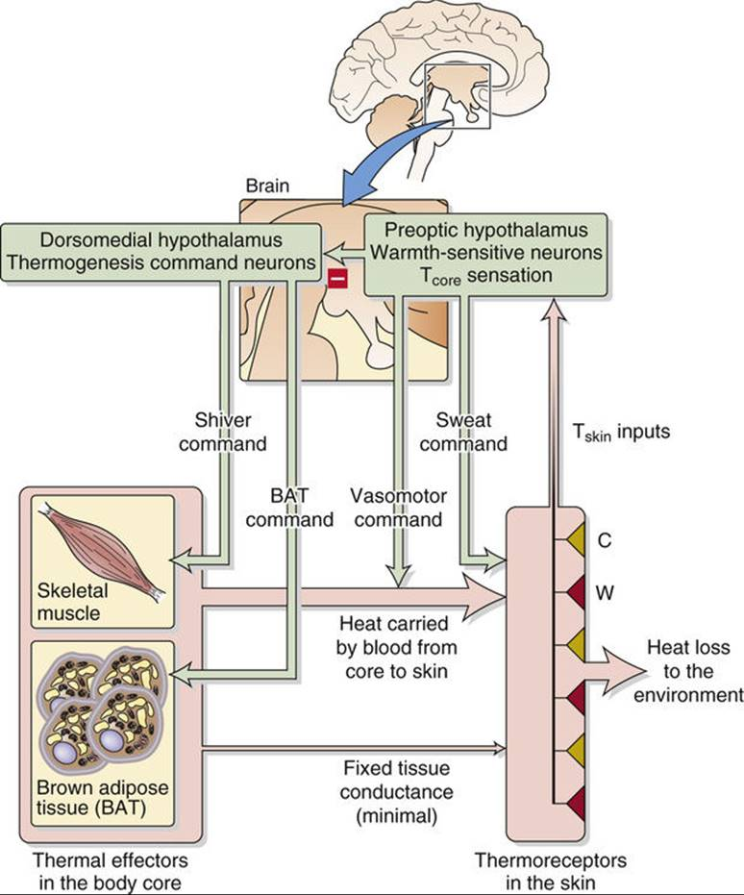
This diagram illustrates the three stages of the thermoregulation mechanism :
- Sensing (Afferent Signals) : Thermoreceptors (peripheral and central) detect temperature.
- Control (Integration Center) : The signal goes to the Hypothalamic Thermoregulatory Center..
- Response (Efferent Responses) : The hypothalamus activates effectors such as shivering, vasoconstriction, sweating, and vasodilation.
Actors of Thermoregulation
- Thermoreceptors Thermoreceptors are sensory receptors sensitive to temperature, allowing for the measurement of any temperature change. There are two types:
1- Peripheral Thermoreceptors: These are sensory neurons whose axonal terminals are scattered in the skin close to blood capillaries. They detect changes in skin temperature, being particularly sensitive to rapid variations.
Two types of peripheral thermoreceptors are identified: some respond to cold, others to heat. Cold thermoreceptors are more numerous than warm ones. The highest density of this type of receptor is found in the face.
Peripheral cold-sensitive thermoreceptors are located in the epidermis. They emit a maximum frequency of action potentials for a temperature close to 30∘C.
Peripheral warm-sensitive thermoreceptors, located in the dermis, have an optimum action potential discharge at a temperature of 40∘C. The discharge frequency of these action potentials increases with temperature when it is between 40∘C and 45∘C. Beyond 45∘C, the frequency of action potentials from thermoreceptors decreases, and from this skin temperature onwards, nociceptors (pain receptors) are stimulated. It is from this threshold that heat physiologically turns into pain. This is also when the heat becomes intense enough to damage skin cells.
2- Central Thermoreceptors: Central thermoreceptors are located in various deep areas of the body: the wall of intra-abdominal organs and large venous trunks, and the spinal cord. Furthermore, thermosensitive neurons are located in the pre-optic area of the anterior hypothalamus. Their discharge frequency varies according to temperature. Most of these neurons are excited by an increase in temperature, but some are excited by a decrease. The stimulation of central thermoreceptors leads to variations in endogenous heat production.
✓ Role of the Hypothalamus in Thermoregulation The hypothalamus contains the thermoregulatory centers. It receives information about skin temperature from dermal and epidermal receptors, and information about blood temperature from central receptors.
- The Body's Response to Heat:
- Effect of Muscular Exercise: In case of physical activity, the organism undergoes an increase in heat production from the skin, and especially an increase in the secretion and evaporation of sweat.
- Sweating (Sudation): It results from a concomitant increase in internal temperature and skin temperature. Sweating proves to be the only thermoregulatory mechanism brought into play when the external temperature exceeds body temperature.
- The Body's Response to Cold: Two phenomena are brought into play, under the control of the thermogenesis center: an increase in heat production and a decrease in heat loss.
- Increased Heat Production:
  - Cold leads to stimulation of hunger, inducing food (and therefore caloric) intake.
  - Cold stimulates the secretion of adrenaline by the adrenal medulla, causing an increase in metabolism.
  - Thyroid hormones are also involved via TSH, resulting in an increase in thermogenesis and the mobilization of hepatic glycogen.
- Decreased Heat Loss: Cutaneous vasoconstriction, initiated by the activation of the sympathetic nervous system, reduces the amount of heat transported by the blood from the deep organs to the skin surface. Fighting the cold also involves behavioral adaptations: wearing appropriate clothing limits heat loss.
Similarly, moving to a protected or better-heated ambient environment significantly limits heat loss.
✓ Heat Exhaustion Syndrome and Heat Stroke These are two complications of increasing severity linked to high external temperatures. It appears that in the absence of appropriate management, heat exhaustion leads to heat stroke. These two syndromes are explained by an increase in temperature, a loss of sodium chloride, and dehydration. They primarily occur in hot and humid environments (where no heat loss is possible via radiation and convection, and evaporation of sweat is limited).
- Heat Exhaustion : Corresponds to dehydration secondary to significant sweat loss. Clinical signs appear within a few days (headaches, nausea and vomiting, dizziness, loss of consciousness, muscular weakness accompanied by cramps, hypotension, tachycardia, and dyspnea).
- Heat Stroke This is a medical emergency. It occurs when thermoregulatory mechanisms are overwhelmed. It combines a major and sudden hyperthermia (>40∘C) with severe neurological disorders (delirium, hallucinations, seizures, coma). These signs may be accompanied by a cessation of sweating, resulting in dry and hot skin, and multi-visceral failure (affecting hepatic and renal functions), often with hyperventilation, tachycardia, and arterial hypotension. Young children and the elderly represent two populations particularly exposed to this syndrome.

Two forms of heat stroke are usually described, depending on the circumstances of occurrence: one due to exceptional climatic conditions, the other resulting from physical exercise generating endogenous heat production that exceeds the body's caloric dissipation capacity. In cases of exercise-related heat stroke, the external temperature is not necessarily excessively high. Individuals engaging in significant physical activity (athletes, firefighters, laborers) are considered at risk. In this form of heat stroke, sweating persists.
Heat exhaustion syndrome is differentiated from heat stroke by the value of the body temperature (which does not exceed 40∘C to 41∘C), and by the absence of neurological signs.
Treatment consists of placing the subject in a cool environment, at rest, and removing their clothes to evacuate the accumulated heat. External cooling methods may be implemented in case of significant hyperthermia: applying ice to different parts of the body (heat dissipation by conduction), ventilation of cool air after wetting the patient's body (heat loss by convection and evaporation). Rehydration is necessary: oral route with glyco-electrolyte solutions, or intravenous route if necessary.

- Fever
Fever is the increase in body temperature observed mainly in reaction to a bacterial, viral, or parasitic infection, or following massive tissue destruction (cancer, myocardial infarction, rheumatic disease). It should not be confused with the increase in body temperature that occurs, for example, during intense and prolonged physical exercise. Its role is not entirely clear. It is possible that it has a beneficial role by increasing the inflammatory response and limiting the proliferation of infectious germs, particularly viruses.
Fever results from a disturbance of the thermoregulatory centers: everything happens as if the hypothalamic thermostat were set for a reference temperature above 37∘C. The physiological responses to heat are respected.
Disturbances in the reference temperature of the hypothalamic thermostat arise from the action of pyrogenic substances (pyrogens). Lipopolysaccharides of bacterial origin, as well as bacterial endotoxins, possess this pyrogenic property.
Pyrogens can have a direct effect on hypothalamic cells if injected into the brain. In an infection situation, pyrogens are released during the phagocytosis of bacteria by neutrophils. It seems that pyrogens trigger fever by inducing the synthesis of Prostaglandins E1 in hypothalamic neurons. This synthesis can be blocked by aspirin. Like other antipyretic drugs (paracetamol/acetaminophen and corticosteroids), aspirin causes a decrease in body temperature in situations of hyperpyrexia. Antipyretic drugs bring the reference temperature back to 37∘C. Body temperature returns to normal by increasing caloric loss due to cutaneous vasodilation and sweating. The administration of antipyretic drugs to a subject with a normal temperature does not cause hypothermia, as there are few prostaglandins in the hypothalamus in the absence of endogenous pyrogens.
II – Cold
Cold is the opposite sensation of heat and is associated with low temperatures. It is also a relative term in the context of heat transfer: a body is described as “cold” when it is in thermal contact with another body of higher temperature, from which it can receive heat.
Theoretically, the lowest possible temperature is absolute zero, corresponding to 0 K on the Kelvin scale and −273.15 °C on the Celsius scale. In practice, absolute zero is unattainable due to its very definition.
Physiological Response to Cold
Cold exposure triggers a thermoregulatory response. The human body maintains its internal temperature within a range compatible with life not too high; to avoid breaking certain chemical bonds such as hydrogen bonds that would denature proteins, and not too low, as insufficient molecular motion would prevent the chemical reactions essential to life.
The normal range of body temperature (normothermia) generally lies between 36.5°C and 37.5°C, although significant variations may occur due to fever, extreme cold exposure, intense exercise, or the menstrual cycle in women (an increase of about 0.5°C in the morning during the second phase of the cycle).
The body ; specifically the hypothalamus determines a set point, which is close to 37°C, representing the optimal temperature for vital functions. The hypothalamus acts as a thermostat, maintaining a balance between heat loss and heat production. When body temperature falls below this set point, thermogenic mechanisms (heat-producing processes) are activated to restore normal temperature.

- Thermoreceptors and Thermoregulatory Mechanisms

Thermoreceptors : Central (able to detect temperature variations as small as 0.01°C) and Peripheral (also sensitive to variations of 0.01°C) detect decreases in body temperature. A drop in temperature triggers afferent signals that are transmitted to the integrating center, the hypothalamus, which exerts its regulatory effects via the autonomic nervous system by acting on blood flow, adipose tissue, and metabolic activity.
Thus, during exposure to cold, body temperature falls below the hypothalamic set point. The hypothalamus then activates several thermogenic mechanisms:
Reduction of heat loss at the body surface: This occurs through cutaneous vasoconstriction mediated by the sympathetic nervous system. The vasoconstriction reduces thermal exchanges
Chemical Thermogenesis: Catecholamines (particularly adrenaline) released by the sympathetic nervous system act on alpha-1 adrenergic receptors to increase cellular metabolism, primarily in adipose tissue, which is highly sensitive to adrenaline. This stimulation promotes lipolysis and glycogenolysis, thereby enhancing heat production.
In newborns, chemical thermogenesis is an effective mechanism against cold exposure, as they still possess a significant amount of brown adipose tissue, which is particularly responsive to adrenaline.
In adults, however, muscle shivering is probably the only efficient means of increasing metabolic heat production.
- Cold-Related Diseases

- Increased Cardiovascular Risk in Cold Weather
Cardiovascular risk refers to the likelihood of developing or experiencing a cardiovascular disease or event.
Cold air causes an involuntary constriction of blood vessels, which can promote the detachment of atherosclerotic plaques (accumulations of fatty and calcified deposits along arterial walls).
This may lead to:
The onset or worsening of angina pectoris, or even a myocardial infarction;
A cerebral arterial thrombosis, responsible for an ischemic stroke (CVA).
- Severe Cold: Raynaud’s Phenomenon
Vasoconstriction induced by cold and by sudden temperature changes (from warm to cold) can also trigger typical Raynaud’s attacks.
This condition affects about 10% of the population and may occur in isolation (most often) or be associated with another disease or medication.
Raynaud’s phenomenon is a circulatory disorder characterized by a temporary interruption of blood flow (ischemia) to the fingers, leading to poor oxygenation of the tissues.
A Raynaud’s attack typically progresses through three stages:
.
1. Ischemic phase: lasts a few minutes; the extremities become white and cold, accompanied by a "dead finger" sensation. Sometimes, the attack stops at this stage.
2. Asphyxic phase: produces painful tingling in the fingers, which turn bluish due to lack of oxygen.
3. Recovery phase: corresponds to the return of blood flow, during which the fingers become swollen, red, and painful.
- An Increase in Respiratory Diseases During Cold Weather Episodes
In winter, respiratory illnesses become more frequent, a phenomenon that can be explained by three main factors:
- Inhalation of cold air cools the mucous membranes of the upper respiratory tract, which can disrupt the normal functioning of the body’s defense mechanisms against infections.
- Cold temperatures also cause a reduction in bronchial diameter, which may sometimes impair breathing.
- Population crowding in enclosed and poorly ventilated spaces (e.g., public transport) increases the risk of infection transmission.

- Cold-Related Diseases:
During the winter season, there is a noticeable increase in various illnesses, particularly affecting individuals who are more vulnerable to cold exposure (infants, the elderly, and patients with chronic or immunocompromising conditions). The most common disorders include:

- Pneumonia: an acute pulmonary infection most often caused by the bacterium Streptococcus pneumoniae (pneumococcus). It may occur as a primary infection or as a complication of a preceding viral respiratory illness such as influenza.
- Bronchitis: an inflammation of the bronchi, usually of viral origin. It typically begins with a dry cough that later becomes productive and resolves spontaneously within two to three weeks in otherwise healthy individuals.
- Influenza (Flu): a highly contagious viral infection that can cause severe complications in vulnerable populations, including the elderly, infants, pregnant women, and patients with chronic diseases.
- Bronchiolitis: a contagious viral respiratory infection occurring in epidemic form during winter, primarily affecting infants. It manifests as coughing and wheezing, which may appear alarming but are generally benign. Strict hygiene measures and medical monitoring are recommended.
- Otitis, gastroenteritis, rhinopharyngitis, and tonsillitis: these infections also occur more frequently in winter, particularly among young children and infants, due to confinement and close contact in poorly ventilated environments.
- Chilblains (frostbite of mild intensity): characterized by painful swelling, redness, and itching of the extremities (hands, feet, ears). They result from poor vascular adaptation to cold exposure and are more common in individuals with circulatory disorders.

