LETTERS
A letter is a written or printed message, typically sent from one person to another, containing information, thoughts, or feelings. It is a type of communication that can be formal or informal, personal or professional.
Letters can also be:
1. Handwritten or typed
2. Sent through postal mail or email
3. Long or short
There are several purposes for which letters are written or sent. A few of them are:
1. Communication with friends and family
2. Business correspondence
3. Official notifications
4. Personal expression and reflection
5. Historical record keeping
In this digital age, letters have evolved to include;
• Emails
• Text messages
• Social media messages
• Online forums and discussions
- Informal Letters
Informal letters are casual and not written for official purposes. They can be semi-formal or friendly, with semi-formal ones addressed to older relatives like parents or uncles. The focus here is on informal letters written to friends, including their features and format.
- Features of Informal Letter
An informal letter is written to close acquaintances like friends and family, using casual and relaxed language. It is flexible in content, allowing the sender to share information, invite, inquire, or educate. Contractions like "won’t" and "can’t" are common, and the tone is chatty and informal, unlike formal letters which require formal language.
2. Format for Informal Letter
The following is the format of an informal letter.
a. Address: This is written in the top corner of either the left-hand (Block format) side or the right-hand (Indented format) side of the paper. It informs the reader of where the letter is written from or who is writing the letter.
b. Date: It is written under the address. It helps the audience to know when the letter was written.
c. Salutation: It serves as a form of greeting. It is done with - Dear+name of the recipient/audience.
d. Introduction: It is where the writer opens the conversation. The writer can say a word of greetings, and also indicate the reason/idea for writing the letter.
e. Main Body: It is in the main body that the writer provides the details of the letter. This could be divided into paragraphs, depending on the number of points or ideas one wants to discuss.
f. Conclusion: This serves as the ending note of the letter. It should be ended in a friendly manner. The writer could summarise all the points discussed in the main body.
g. Subscription: It can be done by saying yours ever, your loving friend, and others. Then the name of the writer follows.
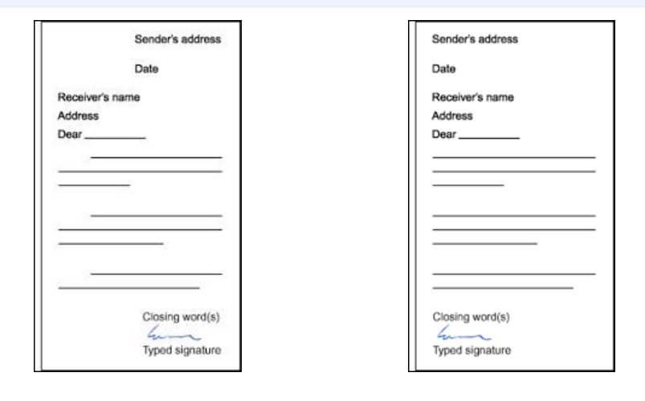

Task 1:
- Describe a recent holiday or adventure you experienced, sharing funny or touching moments, and what you learned or enjoyed most.
- Write about a hobby you love—whether it's playing a sport, painting, reading, or playing an instrument—and explain why it’s special to you.
3. Share about someone in your life—family member, friend, or even a celebrity—who motivates or influences you, and how they have impacted your outlook.
4. Describe what you imagine your life to be like in five or ten years, including your goals, aspirations, and the kind of person you hope to become.
5. Recall a humorous or awkward situation you’ve experienced, and tell your friend how it happened and how you felt afterward.

