ICT, concepts and feffinitions
To define Information and Communication Technologies (ICT), we are supposed to define the following three components: information, communication and technology.
a. Information :Information has two meanings from a technical point of view: information is a sign, a symbol, an element that can be transmitted and stored;
b. Communication
Communication is how information flows. It is carried out through a network which includes at least one transmitter, a transmission channel and a recipient (the receiver).
c. Technology
Technology is the application of a design technique to the realization of a product.
d. Information and communication technologies (ICT)
Yannick Chatelain:
Information and communication technologies (ICT) bring together all the techniques that contribute to digitizing and digitizing information, processing it, storing it and making it available to one or more users. .
e. ICT or NICT?
The term NICT was often used in French-speaking literature during the 1990s and early 2000s to characterize certain so-called “new” technologies. But the definitions provided are generally vague or equivalent to those of ICT. The qualification of “new” is ambiguous, because the scope of so-called new technologies is not specified and varies from one source to another. Due to the rapid evolution of technologies and the market, innovations declared “new” find themselves obsolete a decade later.
Conclusion: ICT = NICT
f. Information and communication technologies for education (ICT)
ICT = ICT + Education
Information and communication technologies for education (ICT) cover digital tools and products that can be used in education and teaching, such as, for example, the Moodle platform
2. Different types of ICT
According to the OECD (Organization for Economic Co-operation and Development), the ICT sector is the sum of three sectors: the IT sector, the electronics sector and the telecommunications sector. We therefore distinguish the following categories relating to the ICT3 sector:
• The IT sector in which we have: IT equipment, office machines, personal computers, large computers, servers, network equipment, peripherals, cards etc.
• The electronics sector (microelectronics) in which we have: electronic components, semiconductors, printed circuits, consumer electronics equipment (televisions, radio receivers, disk players, video recorders), measuring instruments, navigation instruments , computers, production etc.
• The telecommunications sector in which we have: professional transmission equipment, switches, relays, terminals (fixed or mobile) intended for users, cables, optical fibers, etc.
3. Advantages of ICT:
ICT makes it possible to:
• flexibly access information (the Intranet allows information to be retrieved from all workstations, whatever the time),
• facilitate the sharing of information (Internet, Intranet),
• encourage group work (groupware, workflow, collaborative platforms),
• simplify data exchanges between companies or between sites (EDI),
• facilitate communication and cooperation between team members (mailing list,
• blog, wiki),
• establish a collective memory.
4. ICT tools
A. Computers
There are generally three layers in the composition of a computing machine:
• The “hardware” material: it corresponds to the physical machine, notably composed of the processor, central memory and peripherals, all communicating via a bus.
• Operating system software: it is a set of programs which is placed the interface between hardware and application software. In particular, it allows these software
applications to use the hardware resources of the machine
• User software “software”: these are programs that allow the user to to carry out tasks on the machine.
i. The microcomputer
The microcomputer is made up, among other things, of 3 fundamental elements:
• The microprocessor: it executes the instruction it read from memory. It is the “brain” of microcomputer.
• Memory: it stores and restores information in the form of binary words.
• input/output interface boxes: they serve as the “arm” of the microcomputer. They manage the interface between the microcomputer and the exterior (made up of peripherals: printer, keyboard, screen) All these components are connected to each other by different buses.
ii. Central unity
• assembly composed of the box and the elements it contains.
• must be connected to a set of external devices.
• a computer is generally composed of at least a central processing unit, a screen (monitor), a keyboard and a mouse,
It is possible to connect a wide variety of external devices to the input-output interfaces (serial ports, parallel port, USB port, firewire port, etc.): printer, scanner, external storage device, camera or digital camera
iii. The motherboard
The components supported by the motherboard are:
the microprocessor, the chipset, the RAM memory, the expansion connectors (ISA bus, PCI bus, AGP bus) the BIOS, the IDE connectors, the clock, a power connector, the different buses, the standard connectors for the keyboard, the monitor, the mouse, various other components.
Role of the motherboard:
• serves to interconnect all the components of the computer and receives all the essential elements for the proper functioning of the computer.
• is made up of numerous circuits allowing good management of all data flows
• the chipset, a set of essential electronic components, which links the processor, memory and peripherals.
Most motherboards offer the following connectors:
• Serial port, allows you to connect old peripherals;
• Parallel port, allows you to connect printers;
• USB ports (1.1, low speed, or 2.0, high speed), allow you to connect more recent peripherals;
• RJ45 connector (called LAN or Ethernet port) used to connect the computer to a network. It corresponds to a network card integrated into the motherboard;
• VGA connector (called SUB-D15), allows you to connect a screen. It corresponds to the integrated graphics card;
• Audio jacks (Line-In input, Line-Out output and microphone), for connecting loudspeakers or a hi-fi system, as well as a microphone. This connector corresponds to the integrated sound card.

iv. The CPU (Central Processing Unit) processor
CPU: When we manage to put all of its components in a single integrated circuit, we call it a “microprocessor”. allows you to manipulate digital information, that is to say information encoded in binary form (Allows you to execute instructions stored in memory).
Characterized by :
• its clock frequency (in MHz or GHz)
• The number of instructions per second that it can execute (in MIPS)
• The size of the data it is capable of processing (in bits)
Basic architecture of a microprocessor
The essential parts of a processor are:
• The Arithmetic and Logic Unit: supports basic arithmetic calculations and tests.
• The Control Unit
• Registers, small memories (a few bytes),
• The input-output unit allows the processor to access the computer's peripherals.
• The sequencer, which allows the different elements of the processor to be synchronized
• The clock which synchronizes all the actions of the central unit.
Computers have become "multi-core", that is to say they have several processors to carry out the required tasks more quickly. So :
• Dual Core = 2 cores
• Quad Core = 4 cores
• Hexa Core = 6 cores
• Octa Core = 8 cores
There are different models of processors and this technology is evolving rapidly. Processors from the AMD and Intel brands are the most frequently encountered.
In the Intel brand for example, we generally see the models:
• Intel Core i3 which corresponds to the entry-level of Intel Core processors
• Intel Core i5 which constitutes the mid-range
• Intel Core i7 and Intel Core i9 which are of the higher range
v. Computer memories
• A “memory” is an electronic component capable of temporarily storing information. A memory is characterized by:
o Its capacity, representing the overall volume of information
o Its access time, corresponding to the time interval between the read/write request and the availability of the data.
o The computer contains different levels of memory, organized according to a memory hierarchy.
The unit of memory: the bit or the byte
The basic data manipulated by the physical machine is the bit (Binary Digit) which can only take two values: 0 and 1 These 0 and 1 correspond to the two voltage levels (0-1 and 2-5 volts) admitted for the electrical signals coming from the transistors which constitute the physical circuits of the machine.
Number of representable combinations, in binary, relative to the number of bits:

Data storage
In computing, to express the quantity of data that a medium can contain (hard disk, key USB...), we use the term: byte (o) or bytes (b) in English. We can add prefixes to this term:
As for units of measurement such as weight, distance (kg, km, etc.), a table allows you to better understand the order of magnitude:

Memory categories
• Volatile memory: the contents of the memory only exist if there is a power supply (typically cache memories and central memory)
• Permanent, mass memory: large capacity memory whose content remains the same without power supply (typically hard drive, USB key, memory card, CD, DVD)
RAM (Random Access Memory) This is a memory accessible for reading and
writing, It is an internal volatile memory. It makes up the central memory and the caches
Two structures:
• DRAM - Dynamic RAM (access time: 60 nano seconds)
• SRAM - Static RAM (access time 5 nano seconds)
Read only memories: ROM (Read Only Memory)
• Memory accessible for reading (150 ns), Internal non-volatile memory.
• Once the information is recorded, it cannot (or is difficult) to be modified.
Flash memories: compromise between the two types of memory:
• Memory accessible for reading and writing
• Non-volatile memory
• Longer access time than RAM Peripherals

vi. Peripherals
A “peripheral” is any electronic equipment that can be connected to a computer. Here is
some examples :
• A screen allows you to display the contents of the computer.
• A keyboard and mouse are essential to communicate with the computer.
• Speakers allow you to listen to sound files. Some screens have built-in speakers.
• A webcam is a small camera placed on a computer that allows you to film images
and transfer them to the computer. It can also be integrated into the screen of
the computer.
• A printer allows you to print files on paper. Some printers have
also a "scanner" function which is used to convert a "paper" page into a file readable by
the computer.
• A modem is a small box that allows you to connect to the Internet.
• An external hard drive is a hard drive embedded in a solid case and which connects to
a computer via USB.
• The card reader allows a computer to read information contained on cards:
identity cards, memory cards, etc.
• Device classification
• Devices are often classified into 2 categories:
• Input devices: used to provide information (or data) to the system
computer science. Examples: keyboard, mouse, scanner, webcam, microphone…
• Output devices: are used to output information from the computer system.
Examples: screen, printer, headset, etc.
•
• There are also input and output devices, they allow you to provide
information, but also get information out of the computer. Examples: USB key, card
memory, modem...
• A USB key and a memory card allow you to store data on a small medium
transportable. Memory cards are generally intended to be placed in
cameras, cameras, smartphones…

B. Softwares
A computer without a program is not usable. It is necessary to give him information to
that he collaborates. You must first explain to him what is expected of him and then give him the instructions to act. The set of these instructions is called a program, and the set of programs including available on a computer is called software. The program must be written in a language that the computer can understand.
• Every computer is made up of a set of programs called a system operating system or basic software. This operating system is shipped with the computer by
constructor. The user can add specific and personal programs.
i. Basic operating systems or software:
►Sometimes abbreviated SE, (or Operating System in English, abbreviated OS)
An operating system is a set of control and processing programs that:
• manages the various tasks carried out by the computer.
• controls the different components (hard drive, screen, processor, memory, etc.) of the device
• IT and allows it to function.
• operates the various peripherals (sound card, graphics card, mouse, keyboard, etc.).
• The use of drivers allows the operating system to communicate
and give instructions to devices that could not function without them.
• acts as an interface between the user and the computer hardware. He is the logical intermediary between
the user and the computer. It is loaded first when the device boots.
We find an operating system preinstalled on any type of computing device: computer
personal, smartphone, touchscreen tablet, e-reader, game console, etc.
In 2012, the two most popular operating system families are Unix (including macOS,
GNU/Linux, iOS and Android) and Windows. The latter holds a virtual monopoly on computers
personal with almost 90% market share for more than 15 years.
The main operating systems are classified into two categories:
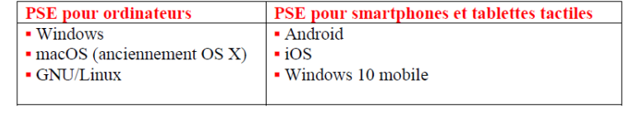
►There are also operating systems for TV like:
• Android TV, developed by Google
• Tizen, developed by Samsung
• tvOS, developed by Apple
• Firefox OS, developed by the Mozilla Foundation, chosen by Panasonic
• WebOS, taken over by LG (formerly by Palm)
ii. Application software:
These are programs developed to meet specific needs. There is software
dealing with standard issues such as programming languages ​​(C language, Visual Basic, etc.)
and Office tools (Microsoft Word, PowerPoint, etc.)
C. Telecommunications networks
Definition
A computer network is a set of devices linked together to exchange information
in the form of digital data (binary values).
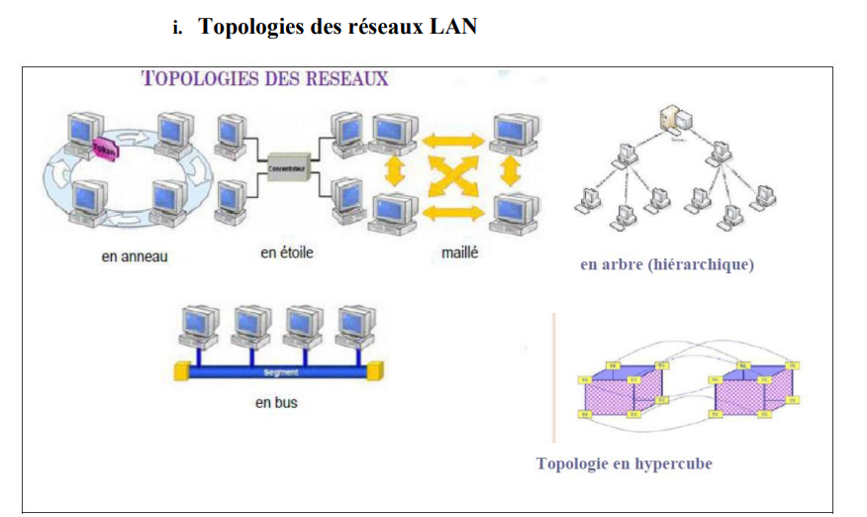
ii. Advantage of networks
Computer networks allow:
1. data transmission: this is the exchange of files between stations (users) on the network. There
Data flow is faster and more secure.
2. communication between people: through email, live discussion, chat,
Skype, etc.
3. data sharing: it is useful to save files shared by several people on a
shared hard drive on a network station. This way makes it possible to have consistent and reliable data.
day.
4. sharing applications (software): it is preferable to install programs used by everyone
the world on a shared disk, rather than installing as many programs as there are machines.
5. sharing of hardware equipment: certain equipment such as printer, fax
can be used by the local user or by other users on the network. Share a
equipment is the act of making this equipment available to other users of the network.
D. Smart chips:
To protect data, businesses and consumers now use smart cards
intelligent in several applications, such as:
▪ Banking operations, ▪ consultation of telephone messages,
▪ Access to electronic mail, ▪ starting the computer,
5. ICT applications
I. Communication spaces: Internet, intranet and extranet
“Internet”: an open network
• The Internet is the global computer network that everyone knows.
• It corresponds to an interconnection of a large number of machines between them.
• This Internet network makes a certain number of hosted services accessible to the public.
• The common point of all these services is the IP protocol (Internet Protocol) which ensures the
communication between all these machines via a browser and a connection
• “Intranet”: an internal network
• An Intranet is a set of Internet services (for example a Web server, a web server,
messaging, a file server) but on the scale of a local network.
• We therefore use Internet technologies which are based on the famous IP protocol but on a scale
of the company network.
• This private network is not visible from the Internet.
• Its particularity is therefore to adopt the major Internet standards but in a private manner.
• The Intranet is particularly suitable for collaborative work.
“Extranet”: a private network
• An Extranet is an extension of a company's information system to partners located
beyond that company’s network.
• This extension is secure so as to only allow access to people
designated.
• In this case, the Internet network is used to convey the information, but
the information is not accessible to the general public.
• An Extranet is therefore neither an Intranet nor an Internet site.
• This is an additional system offering, for example, a company's customers, its
partners or subsidiaries, privileged access to certain IT resources of
the company via a web interface.
II. A database
• A database is a collection of information that is organized in such a way that it can be easily
accessible, managed and updated.
• It is used by organizations as a method of storage, management and retrieval
some information.
• Data is organized into rows, columns and tables and is indexed for ease of reference.
search for information.
• The data is updated, completed or even deleted as and when
new information is added.
How a database works
• A database is stored as a file or set of files on a
disk or a magnetic disk, an optical disk or any other storage medium.
• The information contained in these files can be divided into records.
• These records consist of one or more fields.
• A field constitutes a single piece of information, and each field generally contains
information relating to an aspect or attribute of the entity described by the database.
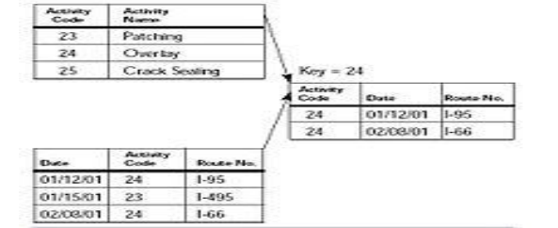
III. Multimedia Audioconferencing:
• Audio conferencing is a technology that allows you to participate live in meetings telephone, with several participants. It is a mode of communication using the principle of voice over IP.
• Audio conferencing is as easy to use as a traditional telephone: you connect the audio conferencing system like any other telephone and on a power supply if
your network does not support PoE. There are also solutions adapted to the technologies of current telephony, both by connecting via USB or Bluetooth to a PC, Mac, tablet, smartphone, etc.
• It is very advantageous in that it allows you to call from PC to PC while limiting
the infrastructure with a single type of cable that of the company's computer network.
• Voice over IP communication constitutes an economical solution for businesses since
it is 10 times cheaper than conventional communication.
IV. Multimedia Videoconferencing
• A technical process which allows visual and auditory communication of several
interlocutors, professionals or individuals, located in separate locations using software
adapted and to webcams.
• The equipment needed to organize a videoconference is relatively simple to install:
each participant must have a computer with a sound card and client software (integrated under
Windows) a camera (webcams) a headset and a broadband line.
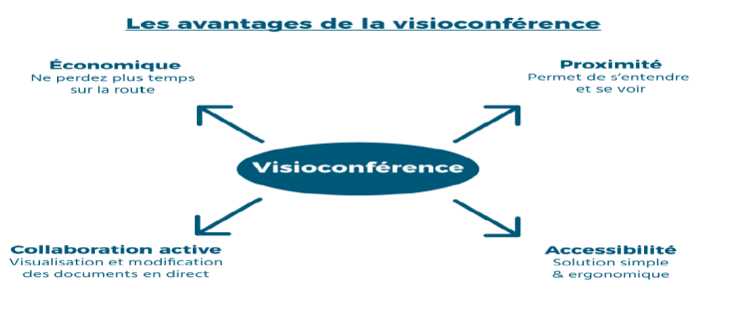
E. Electronic Data Interchange (EDI):
• EDI defines a set of standards and tools for exchanging commercial documents
structured between remote computer applications linked by a network. All of the
partners whether they are customers, suppliers, banking organizations or administrations,
thus exchange paper documents: Electronic Data Interchange (EDI)
• EDI was designed to replace the transmission of information on paper and to overcome
the inefficiency of manual systems. Its goal is to reduce human intervention in the
information processing process. We then speak of dematerialization of information.
• For example, sending an order by fax then entering it by a company operator,
is replaced by the transmission of information which is routed to a company computer
supplier capable of interpreting the order.
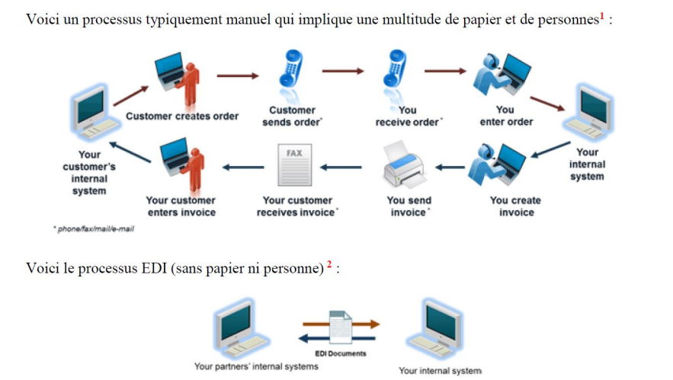
F. The workflow:
• In French: “work flow” or “operational flow”
• It is software that allows you to organize, operate and control a process.
• The workflow is the representation of a series of tasks or operations carried out by a person,
a group of people, an organization, etc. The term flow refers to the passage of the product,
of the document, information, etc., from one stage to the next.
• Workflow is used to model and automate the company's information flows, for example example certain documents such as insurance files, loans or expense reports,must follow a predetermined path during their development. In this way the Workflow defines the routing circuits for each type of file, specifying the
stakeholders, deadlines and operations and approval and validation operations.
• We identify two types of Workflow:
• Procedural Workflow: the routes are defined in advance, this mode is suitable for procedures
structured and repetitive.
• Ad hoc Workflow: users intervene dynamically and adapt the path
depending on the situation.1
• Examples of workflow software for BPM (Business Process Management = management of business processes)

