Round Heads and Cavaliers:
The English Civil War
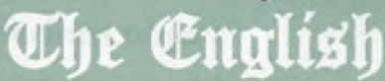
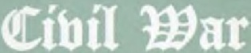
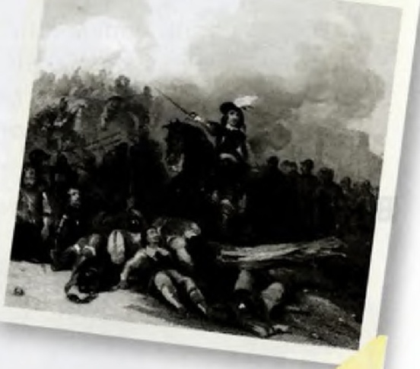
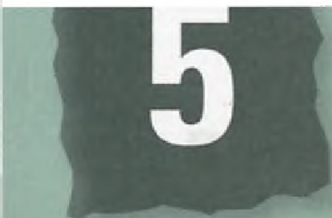Section I: Reading
l\ouubbtab

- Before you read - think and discuss
The English Civil War was a series of armed conflicts fought between Parliamentarians and Royalists which played a key role in the development of parliamentary democracy.
  - What major battles have there been in your country?
  - Why/how were the battles won?
  - Who were the leading figures involved on either side?
  - What, if anything, do you know about the English Civil War?

- Read the text

Roundheads and Cavaliers:
The English Civil War

'Whose blood stains the walls of our towns and defiles our land? Is it not all English?'
Bulstrode Whitelocke, 17th-century lawyer, writer and parliamentarian
I

saac Foot, a \veil-known British intellectual, once said that he judged any man he met by his_ answer to a question about events 300 years earlier. The
question \vas, 'On whose side would you have fought in the Battle of Marston Moor?' He was referring to the largest battle of the English Civil War, which took place just outside York on 2nd July 1644. On one side were the 'Cavaliers', the army of the Stuart King, Charles I, and on the other the 'Roundheads', the army
10 of the English Parliament.
The Civil War (1642-48) was a series of such battles hut also a conflict in people's hearts and minds. It climaxed with the execution of the King and the creation of the only republic the country has ever had.
The clash between King and Parliament revolved around the most fundamental question - how should the country he ruled? Differences in religion and politics bitterly divided families and split friend from friend. Modern estimates suggest that one in every four
or five adult males was caught up in the fighting. 20 Around 150 towns were destroyed, 11,000 houses were burnt or demolished and 55,000 people were made homeless. Nearly 4 per cent of England's population, roughly 100,000 people, died in the fighting or from war - related disease.
The causes of the Civil War were complex but can be reduced to a few simple factors. Charles I was a weak, indecisive yet extraordinarily stubborn character who believed utterly in the divine right of kings. This
meant he believed his power came from God and that 30
no mortal soul was allowed to question his authority. Charles refused to allow Parliament to sit from 1629 to 1640 (a period known as the 'Eleven Ycars'Tyranny'), but Parliament was full of lawyers and historians who were no longer prepared to accept royal absolutism.

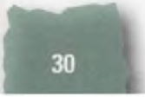
unbbeabs anb l(abalins: be nglisb ibil War

By 1642, a series of arguments over religion, finance and the limits of parliamentary power led both the King and Parliamentarians to recruit men from all over the country who were prepared to choose a side
40 to fight on. On 22nd August, outside the city of Nottingham, Charles raised his personal flag. This was his formal declaration of \Var. But the omens were not good: that night, Charles's flag and most of his temporary headquarters were blown down in a ferocious storm.
October 1642 saw the first great battle of the Civil War at Edgehill, north of Oxford. The outcome was inconclusive. The following year, the balance of power swung the King's way. But in July 1644 the two sides
50 met at Marston Moor and the Parliamentarians were triumphant. After the battle the plain-spoken commander of the parliamentary cavalry, Oliver Cromwell, boasted that 'God made them as stubble to our swords'. This gentleman farmer was becoming the inspirational figure of the parliamentary cause. Cromwell was a deeply committed Puritan with a revolutionary approach to recrniting men. He was uninterested in their social background and simply wanted 'plain, honest men' who had 'the root of the matter in them'.
60 The Puritan religion was the inspiration behind the New Model Army, a 22,000-strong professional fighting force that Cromwell and the parliamentary

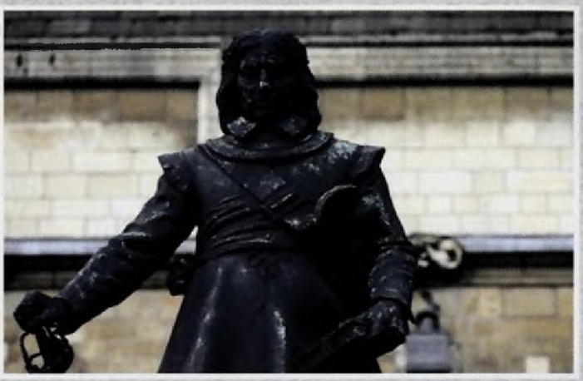
Statue of Oliver Cromwell

from Charles's point of view, the Roundhead, also captured private letters from the King which revealed he was plotting to hire foreign soldiers and to repeal the laws against Roman Catholics. For Cromwell and his fellow Puritans, this was the ultimate betrayal. It was proof that the King could not be trusted.
Charles surrendered to a Scottish army in 1646 but
his endless plotting restarted the conflict in 1648. The 80 outcome was the same as before, but this time the personal consequences were fatal. The King was now denounced as 'Charles Stuart, that man of blood', and a small number of the most extreme parliamentarians, led
by Cromwell, forced an act through Parliament which allowed Charles to be tried for treason. Although the

commander Sir Thomas Fairfa.x.
created in the spring of
trial took place in the open, it, outcome was clear from

1645. Its regiments sang hymns, did not swear or drink alcohol, and were guided by sermons. Royalists mocked the New Model Army soldiers for supposedly bending their heads constantly in prayer. But the sober discipline and religious certainty brought dramatic results. On 14th June 1645, at Naseby in the East Midlands, Cromwell's
70 red-uniformed men won the decisive battle of the Civil War, taking some 5,000 prisoners and securing £1 ()(),000 (£11.2 million today) in jewel, and money. Worst of all,

the start. On a bitterly cold morning in late January 1649, Charles was publicly beheaded. With the word, 'behold the head of a traitor', the executioner lifted Charles's severed head from the floor and displayed it to the horrified crowd. Many were convinced that this was such an extraordinary act that God Himself would immediately split the skies open and bring an end to the world.This did not happen of course, but Charles remains the only English monarch to have been executed.

i--+
l!S
⁹⁰ i5l
:.?e::::
w
.-!,=-
..
-
t:sl
t:t
g'
..

