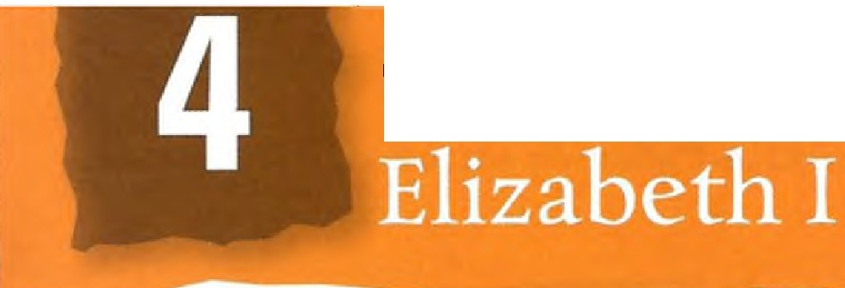
Good Queen Bess:
Good Queen Bess:

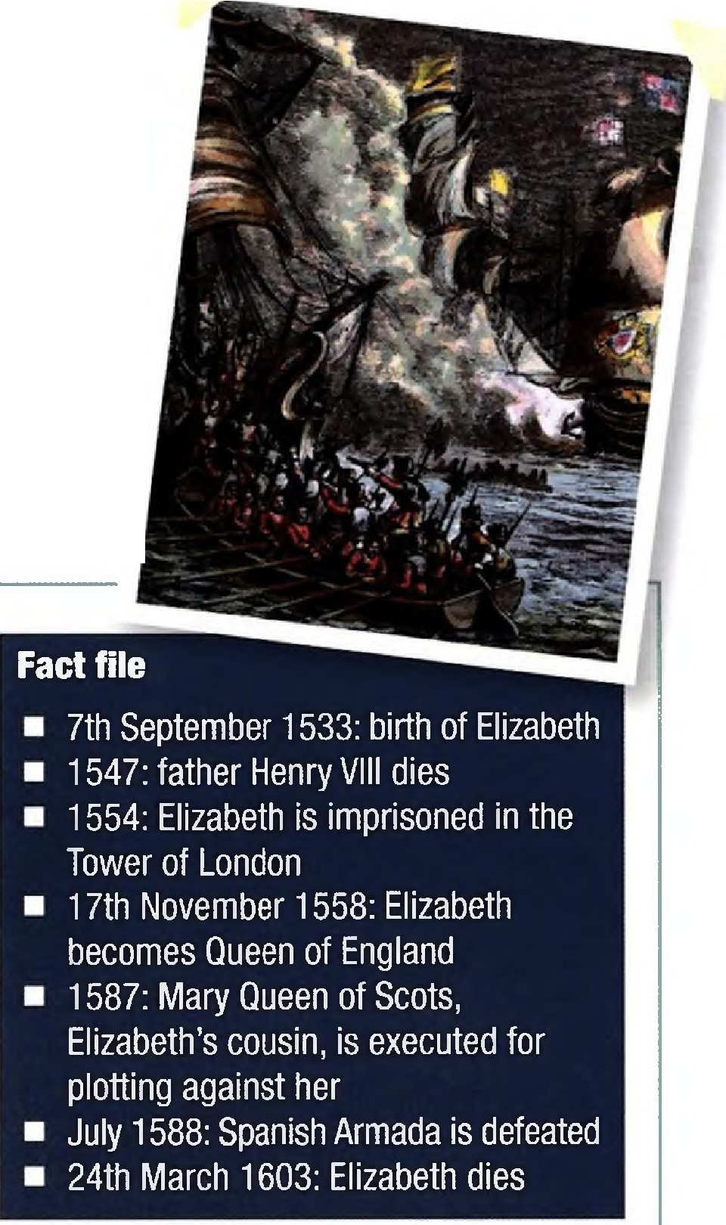Section 1: Reading
- Before you read - think and discuss
Elizabeth I was one of England's greatest queens, who won a famous victory against the powerful Spanish Armada.
  - What great battles have there been in your country's history?
  - Has a woman ever led your country in a time of war?
  - What, if anything, do you know about Elizabethan England?

- Read the text

GOOD QUEEN BESS:
ELIZABETH I
'I know I have the body of a weak
and feeble woman, but I have the heart and stomach of a king, and a king of England too.'
Queen Elizabeth I to her troops at Tilbury, before the arrival of the Spanish Armada

Birth of a daughter
There was just one problem with the birth of the child who would later become Queen Elizabeth I - she was supposed to be a boy. The pre-written court letters announcing the birth had to be quickly changed. The word prince became princes (the Elizabethan spelling of princess) with the addition of a letter ·s·. This unwelcome surprise would cost the child's mother, Anne Boleyn, her life (see Chapter 3). It nearly proved fatal for Elizabeth herself.
Threats to the young Elizabeth
Elizabeth was the daughter of a demonized mother, so it is
1 o remarkab le that she managed to survive the reign of Henry
VIII. When Henry died, Elizabeth was in even more danger. Her Protestant half-brother became King Edward VI and declared that she was illegitimate, with no right to be queen. After his death, Elizabeth's Catholic half-sister
became Queen Mary I. Queen Mary imprisoned Elizabeth in the Tower of London, and tried to collect evidence to show that Elizabeth was plotting against her.
Elizabeth becomes Queen
Not only did Elizabeth survive these threats but she became queen herself when Mary died. Mary had no heir, so Elizabeth
became the third of Henry's children to sit on the throne in 11 20 years. Elizabeth remained queen for 45 years, and became the most idolized of all British monarchs. Today, she is still
celebrated as one of England's finest monarchs, who successfully fought off England's enemies while ruling over a period of extraordinary cultural flowering.
Her father's daughter?
Elizabeth was very like her father in many ways. She looked like Henry, with her father's hair and skin colour, nose and lips. She had much of Henry's character, too - his

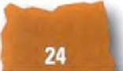
Good Queen Bess: Elizabeth I

intelligence, his strong personality, his eloquence and his
30 irresistible charisma. But unlike her father, she believed in mercy and she was prepared to compromise. She was a practical ruler who avoided extremes - in religion, in politics and (usually) in punishment.
To marry or not
One of the first challenges for the attractive young queen was the question of marriage. Throughout her reign she had a succession of male favourites, most notably Robert Dudley, Earl of Leicester, but she never married . She explained this by saying, 'I am already bound unto a husband, which is the kingdom of England.' It seems
40 Elizabeth realized that marrying a foreign prince would threaten England with foreign domination, while marrying an English nobleman could cause trouble at home.
The Virgin Queen
Elizabeth's powerful image was as Gloriana the Virgin Queen - a golden-haired, white-faced icon in jewels and spectacular dresses. She was not afraid to use her power­ from 1563, portraits of Elizabeth had to be copied from an approved template. When a preacher criticized the Queen in 1579 because she did not want to marry, she ordered that his writing hand should be chopped off. 'God save the
50 Queen!' he cried out after his right hand was severed, raising his hat with his left hand.
The Church of England
Elizabeth followed a cautious path in matters of religion. She restored the Church of England's independence from Rome and under her leadership blended both Protestant and Catholic elements, although it remained technically Protestant. She expected people to conform outwardly and to respect her position as head of the church. However, she was not concerned about their inner beliefs. 'I would not open windows into men's souls,' she explained.
Execution of Mary Queen of Scots
60 Some Catholics believed that Elizabeth's Catholic cousin, Mary Queen of Scots, should be Queen of England. Mary had been ousted from the throne of Scotland and fled to England, where she was put under house arrest. Mary became the focus of numerous Catholic plots against

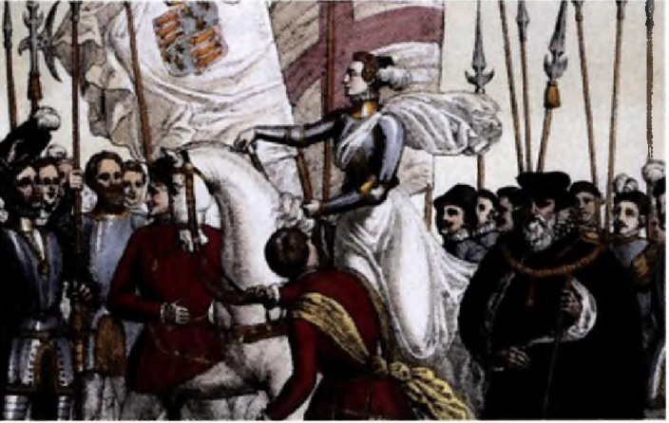

Elizabeth's life. There were many years of conspiracies concerning Mary and warnings about the threat she represented. Eventually, Elizabeth could take no more and Mary was tried and executed .
The Spanish Armada
By now, religious tensions across Western Europe were extremely high. The Catholic Philip II of Spain was 70
outraged by the execution of Mary, and by English attacks on Spanish ships and possessions in the New World. He decided to send a massive Armada against England. The plan was that a fleet of 130 ships would sail from Spain to the Spanish Netherlands. Here, they would pick up a Spanish army and sail for England. However, the Armada was seen in the Channel and beacon fires were lit across England. The English navy, under the command of Sir Francis Drake, prepared itself. In Tilbury, Kent, the Queen
addressed her troops. She gave one of the most inspiring 80
speeches in English history (see quote on previous page). The English navy, helped by the weather, divided and conquered the Armada, to the eternal glory of Elizabeth.
Elizabeth's legacy
Elizabeth ruled England with tremendous style, spirit and flair. She symbolizes the defiant, patriotic liberty of the English perhaps better than any other national figure.
During the time of her reign, it was believed that it was against God's will for a woman to hold power. Her triumph in a man's world is, therefore, all the more remarkable .

