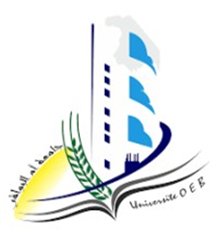
الجمهورية الجزائرية الديمقراطية الشعبية
PEOPLE‘S DEMOCRATIC REPUBLIC OF ALGERIA
Ministry of Higher Education and Scientific Research
Larbi Ben M'Hidi University, Oum El Bouaghi-Algeria
Faculty of Economic, Commercial, and Management Sciences
Department of Finance and Accounting

English paper
title

Submitted by: Field: Accounting/Finance/Audit
Full name Group:

Academic year: 2024/2025

References

