Exercise on XML - JSON Mapping
Exercise 1:
Rules for converting XML elements to JSON format
A single structures XML element can be available in seven variations:
- An empty element.
- An element with pure text content.
- An empty element with attributes.
- An element with pure text content and attributes.
- An element containing elements with different names.
- An element containing elements with identical names.
- An element containing elements and contiguous text.
The following table illustrates the transformation rules of an XML element to JSON:
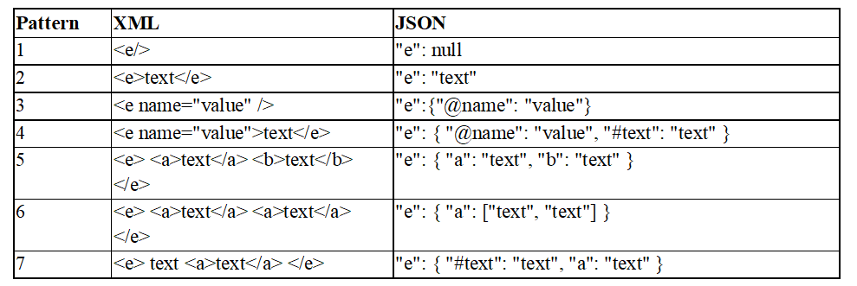
Exercise 1:
Translate the representation of the following XML data into JSON format:
<Root dbName = "gestion">
<description> Données sur les clients et les articles </description>

<Clients>
Informations sur les clients enregistrés dans la DB
<Client id = "C1">
<Name> Mohamed </Name>
<Address> O.E.B </Address>
</Client>
<Client id = "C2">
<Name> Ali </Name>
<Address> O.E.B </Address>
</Client>
</Clients>

<Products>
Informations sur les articles enregistrés dans la DB
<Product id = "P1">
<Name> Product 1 </Name>
<Type> Type 1 </Type>
</Product>
<Product id = "2">
<Name> Product 2 </Name>
<Type> Type 2 </Type>
</Product>
</Products>
</Root>

